Mehak Mann

CSE 190e

09/04/2018

“Prompt Me” App Prioritization & Timing Estimates

### App Description

*Prompt Me is an app that suggests writing prompts (posted by other users) according to the user’s filters (i.e. by genre, most recent, etc.). Writers can “bookmark” prompts that they like and even respond with a short response of their own. If their responses get enough likes, writers can turn their responses into larger “projects.”*

*Writers can gain “followers” when people like their prompts/responses or follow their projects. To make the writing process easier, users have access to a private “library” with folders such as “bookmarks” and “projects”; project folders are created from bookmarked prompts (and designated to those bookmarked prompts) to give writers a comfortable writing interface.*

*The purpose of this app is:*

* *To build a community where writers inspire each other.*
* *To keep writers inspired by giving them a comfortable writing interface suitable for all situations.*

*Basic Paper Prototype Layout*

*(Additional functionality slides like “Filter/Add” left out):*

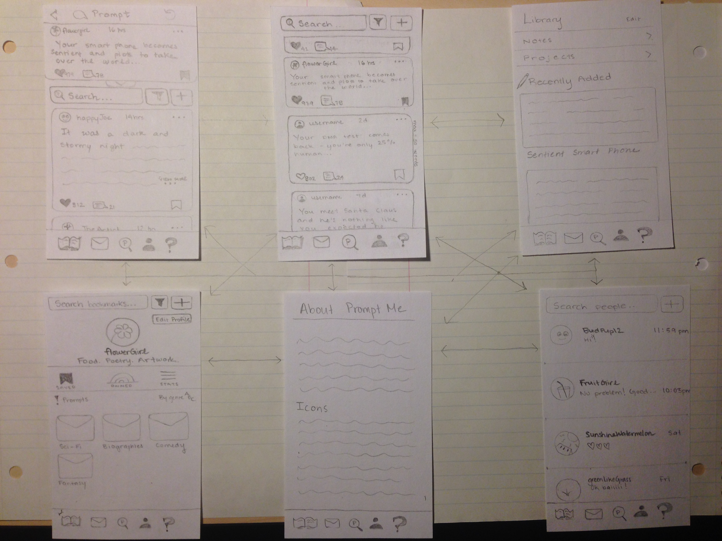

Expanding Target Market

* Creative writing prompts (writers, people with ideas)
* Academic-based, research prompts or college-essay prompts (i.e. Stanford prompt from 2003): students, professors, academics

Bookmarking function should be applicable to all prompts.

### Prioritization of Features

**I. Must develop:**

1. Prompt-suggesting interface
   1. Option A: Prompts are suggested by app’s users
   2. Option B: Prompts are extracted from the Internet (web scraping) - taken from certain social media pages dedicated to writing-prompts
2. User’s ability to filter prompts (*i.e. by genre, most recent, etc.)*
3. User’s ability to “like” and “bookmark” prompts, as well as follow other users
4. User’s profile, which includes “bookmarked” prompts, prompts they’ve written (assuming Option A), and number of followers/following

**II. Would like to develop:**

1. User’s “library” - invisible to public eye, personalized for user’s comfort/aesthetic
   1. User’s ability to “import” bookmarked prompts to the writer’s library, which creates a project folder designated to that prompt and gives the user a comfortable writing interface.
   2. Ability to “share” writing, making it public again:
      1. Would be posted underneath the prompt’s page
      2. Would also be included under user’s profile

* Purpose: if other users liked one of the writer’s stories, they could visit the writer’s profile to view other stories by them.

**III. Could develop if I have more time:**

1. Add features for personalizing writing interface (located within library)
   1. Writing interface has two modes: white text on black (night) and black text on white (day)
   2. Multiple documents can be stored in a folder
2. User’s Stats Feature (i.e. keeps track of number of prompts submitted, number of stories submitted, “liking” history, includes chart depicting number of hours spent writing daily on app, etc.)

**IV. Likely won’t develop because of lack of time or knowledge:**

1. Option B underneath “Prompt-suggesting interface” (see Section I)
   * Lack of knowledge base on web scraping (use API instead)
2. Make “library” accessible by multiple devices (phone app, computer) through the cloud
   * Would require building a website for the app as well
   * Lack of knowledge base on setting up private cloud storage service

Reflections from Testing: Edits to Paper Prototype Design

(See “Test Cases” Hand-Out for more details)

Solving User Confusion:

*Icons:*

I’ve resolved to add an “icon” definition tab to the “About” page to make the app accessible to a variety of users (especially academics).

Private vs. Public Issue

*Private:*

I’ve resolved to make bookmarks a private entity (just like they are in Instagram) and a folder within “library,” rather than separate from the library.

*Private or Public (Marketing Strategy):*

In reverse, I’ve decided that users can choose to make “projects” (based on prompts) public or private (or paid - Patron system; people can “follow” them for a price).

*Public:*

Posts (whether comments or responses) and prompts are to be kept public. Number of bookmarks will show on prompts.

Library vs. Bookmark

Bookmarks will now be located within the library.

New project creation:

There will be a way to create projects within the library (either an “add” function in the “projects” section, “bookmarks” section, or holistic “library” section).

Following up on User #1’s critique, I’ve decided that new projects can only be created in the “Library” section.

User Profile:

Contributed Posts (sortable by responses and prompts), statistics (some of which can be made private/public), & Bio. Might *also* have a separate tab for projects if applicable?

Brings up new questions:

Should the user be able to search by projects/responses in addition to just prompts?

Responding to a prompt:

The main “sharing” or “posting” utility *for responses* should be through library >> projects.

However, the “plus” icon is straightforwardly used for creating “prompts.” It should represent making “responses” on actual prompt page.

Should there be an added functionality for saving, to show the user that their writing saves automatically?

### Implementation Schedule

**Total estimated time: 20 hours**

|  |  |  |  |
| --- | --- | --- | --- |
| Date | Work time | Feature | Estimated time to complete |
| 9/1 - 9/3 | Out of class time | Prompt-Suggesting Interface (Option A/B) + Individual prompt pages | 4 hours |
| Filter | 1 hour |
| Create User profile (edit bio, automatically-  updating stats: prompts/stories written, followers/  following) | 2 hours |
| Add User Functionalities (Liking/Bookmark-  ing prompts & stories) | 0.5 hours |
| 9/4 | 1.5 hours class time + Out of class time | User library: | 3.5 hours total |
|
| Importing bookmarks feature; Creation of project folders | 2 hours |
| “Share writing” feature | 1.5 hours |
| 9/5 | 1.5 hours class time + Out of class time | 1) Test product  2) Writing interface features for personalization | 3 hours |
|
| 9/6 | 2 hours class time + Out of class time | 1) Catch up  2) Test product  3) Work on “Likely Won’t Develop” Features | 4 hours |
|
| 9/7 | 1.5 hours class time + Out of class time | Test product | 2 hours |
|